**Lab 2**

* **Compile and run the above code. Start the acceptor first and then the requestor with appropriate command line arguments. Describe and explain the output.**
* **Now run the code again, but reverse the order of program’s execution. Start the requestor first and then the acceptor. Describe and explain the outcome.**
* **Add a time delay of 5 seconds in the ConnectionAcceptor process just before the message is written to the socket, then run the program. This will show you the blocking at the receiver. Show a trace of the output of the processes.**

**Task 1**

**Acceptor.java**

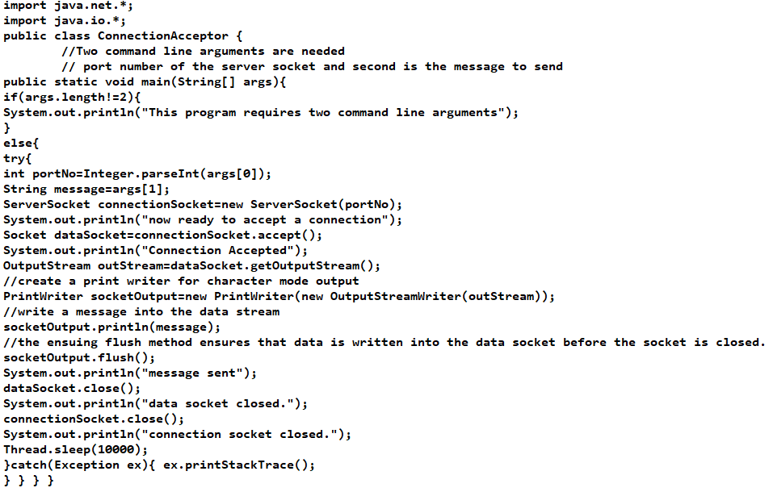

**Requestor.java**

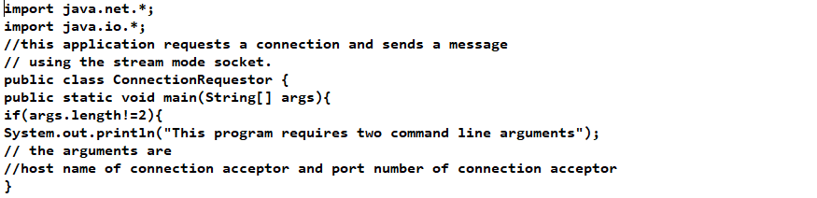

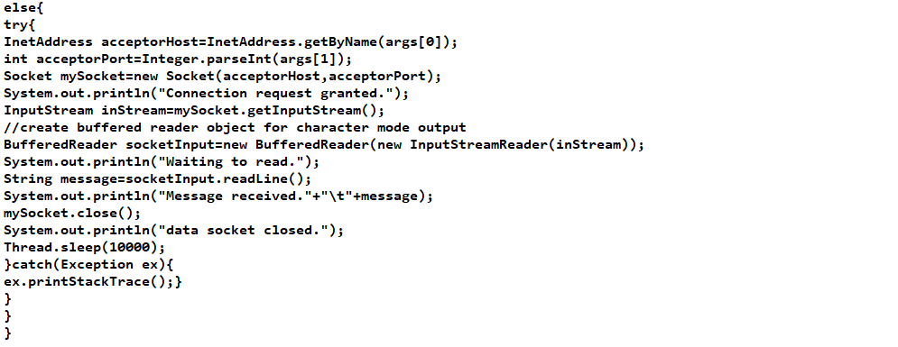

**Output:**

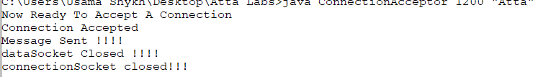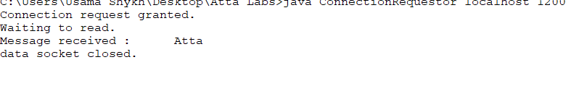

**Task2**

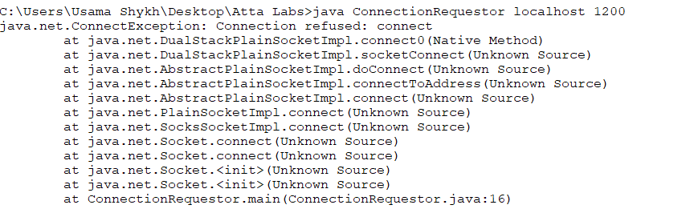

**Task3.**

